St Bernadette Catholic Primary School

Special Educational Needs and Emotional Wellbeing Support for Home Learning

Supporting emotional well-being
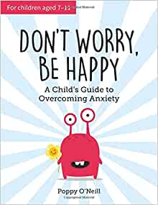
For pupils in KS2 there is a really useful book for managing worries called “Don’t Worry, Be Happy” by Poppy O’Neill.
It works like a daily exercise to write down ideas , complete activities and re-frame thoughts.

We would advise that you read it first and maybe start with one section and do it together or just parts. It’s the talking and acknowledging that all feelings are valid and that there are sometimes ways that we can help ourselves by developing strategies that will help now and in the future.

