St Bernadette Catholic Primary School

Special Educational Needs and Emotional Wellbeing Support for Home Learning

Maths Ideas
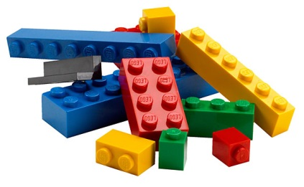
Lego Maths
- Can they find two bricks that add to 10 ?
- How many different ways can you do this?
( reinforcing number bonds to 10)
- Can you find 5 bricks of 2 ?
- How many dots are there in total ?
( developing repeated addition for multiplication)
Repeat with different size bricks .
- Quick addition of any two bricks without counting .
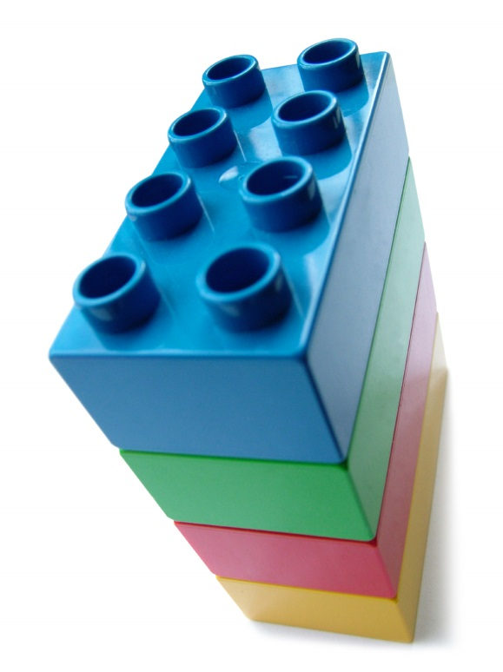
Lego Towers ( developing measuring / estimating/ calculations )
- Can you make a tall tower from 6 dot bricks ?
- How tall is it? Use a ruler / tape measure and record how tall in cm.
- Can you make a tall tower in 4 dot bricks ?
- Is it taller / shorter ? By how much ?
- Can you make the tallest tower using any bricks ?
- Can you make it stable so it doesn’t fall? What do you need to do ?
- How tall is it ? Can you estimate how tall it is ? Write it down . Measure accurately . Write it down . How close were you ? Work it out. Write it down.

What else can you do with Lego ?
- Can you sort by colour , size , shape ?
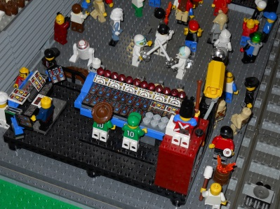
- Can you use it for area ?
- Can you make a birds eye map of your room ?
- Be creative .
- Have fun .

