**St Bernadette Catholic Primary School**

ST%20Bernadette%20School%20LOGO%2011-04COL

|  |  |
| --- | --- |
| **Collective Worship** | |
| **Version** | V 1.0 |
| **Based on Model Policy:** | N/A |
| **Name/Title of responsible committee/individual:** | Curriculum |
| **Date issued:** | September 2019 |
| **Review frequency:** | 2 years |
| **Target audience:** | Curriculum |

Our Mission Statement, ***“learning to grow in knowledge, faith and love through friendship with Jesus and Mary“,*** underpins all that we do at St Bernadette Catholic Primary School.

The Governing Body shall conduct the School with a view to promoting high standards of educational achievement.

St Bernadette Catholic Primary School is committed to eliminating discrimination, advancing equality of opportunity and fostering good relations between different groups.  These factors were considered in the formation and review of this policy and will be adhered to in its implementation and application across the whole school community.

The School will promote the Gospel values together with the values of democracy, the rule of law, individual liberty and mutual respect and tolerance of those with different faiths and beliefs. Staff and governors will actively challenge pupils, colleagues or parents expressing opinions contrary to fundamental British Values, including ‘extremist’ views.

|  |  |  |
| --- | --- | --- |
| **Version** | **Date** | **Notes** |
| V1.0 | September 2019 |  |
|  |  |  |
|  |  |  |
|  |  |  |

**Mission Statement**

Our mission is:

Learning to grow in knowledge, faith and love

Through friendship with Jesus and Mary

Our vision is to inspire our children:

- To become children of knowledge, faith, hope and love

- To become confident, independent learners for life

- To keep safe, be strong and make a positive contribution to society

**Statement of intent:**

Collective Worship at St Bernadette Catholic Primary School provides opportunities for all staff and children to come together to worship God. Whilst respecting diversity of belief and commitment, it will be Catholic in character, reflecting the liturgical tradition of the Church and having Christ at its centre.

It will take into account the religious and educational needs of all who share in it:

* Those who form part of the worshipping community in Church
* Those for whom school may be their first and only experience of Church
* Those from other Christian traditions
* Those from other faith backgrounds.

It will be an educational activity or experience.

* To which all can contribute
* From which all can gain.

**Aims**

Through our worshipping together we aim to:

* Enable and encourage a sense of belonging to a community with a common ethos
* and shared values of ‘Love, Learn, Believe’
* Respond to and celebrate life by taking time out to ‘wonder at’
* Contemplate something of the mystery of God
* Enrich the religious experience of all members of the school community
* Reflect on spiritual and moral issues
* Build a firm foundation for liturgy.

**Who?**

* The governing body are responsible for ensuring that the school has a current Collective Worship policy
* The Headteacher is responsible for ensuring that Collective worship is provided for each child each day
* Class teachers are responsible for planning and enabling Collective Worship to take place daily
* Children will have the opportunity to take an active part in daily Collective Worship.

**Where?**

Collective worship can take place:

* Within the classroom
* In the school hall
* Outside areas belonging to the school

“As a rule all acts of Collective Worship should take place on the school premises.

However, the governing bodies of grant maintained, aided and special agreement schools have discretion to organise Collective Worship elsewhere on special occasions.”

(Education Reform Act 1988)

**When?**

It is a legal requirement that every child must have an opportunity to take part in

Collective Worship every day. To ensure that Collective Worship is a meaningful and prayerful opportunity for all participants it needs to occur at the most appropriate time for the class/ key stage / school. Class teachers are encouraged to look at their weekly curriculum and place Collective Worship at a time which enables the children to have a quality experience.

**How?**

Leader: it can be led by:

* Headteacher/RE Coordinator, Deputy head, Father Brian
* Class teacher
* Children
* Visitors

In order to provide children with quality experiences of Collective Worship, teachers at St Bernadette Catholic Primary School will:

* Ensure that the theme, focus, delivery, length and resources are appropriates to
* the interests, age range, backgrounds and abilities of learners (time: approximately one minute for each year of a child’s life)
* Set an appropriate atmosphere with a sense of order and occasion, including entry
* and exit (use of music / lighting)
* Provide a focus using artefacts, candles, symbols etc
* Respect the freedom of learners and staff in the invitation to prayer and worship
* Ensure the possibility of conscious, active participation of all present
* Teachers will use a variety of building blocks
* Short address/personal experience
* Readings: Scripture / poetry / story
* Drama / dance / song / role play
* Artefacts / posters / natural materials
* Time for reflection / silence
* Prayer: informal / formal (Psalms / children’s own prayers etc)
* Responses (e.g. saying / singing)

**Planning and Recording**

Planning will be done with reference to:

* Margaret Carswell
* The Way, The Truth and The Life topics,
* the Church’s seasons,
* significant dates,
* The whole curriculum
* Local, national, world events

**What to include on planning sheet for Collective Worship.**

When Teachers plan Collective Worship...

**Preparation**: When, where, who, what? What resources will I need? Create focus. Send Invitations

**Gathering**: How will we begin / enter – to music? Create an atmosphere of prayer. Use a ‘gathering chant’ Come in procession.

**Listen:** Reading from scriptures, psalms, poems etc. Use power point. Pause at times for quiet contemplation. Dramatise the readings.

**Respond:** What do pupils will do. Quiet reflection, formal / informal prayer / respond to bidding prayers. Place stone at foot of cross etc.

**Go Forth:** What will I do to help the children take the message away with them – prayer card, picture, common prayer

**When children plan Collective Worship:**

**Gather**

• What music might you play?

• How will you arrange the children?

• Will you light the candle(s)?

• Can you find an appropriate picture / poster / artefact? – explain it.

**Listen**

• Who will read?

• What will you read? (Scripture / Prayer / Psalm / Poem / Story / Hymn)

• Will you act out the reading? Or use a Power Point presentation?

**Respond**

• How will you help your friends to reflect on what they have read?

• Will you say prayers that need a response?

• Who will lead the prayers?

**Go Forth**

• What do you want your friends to take away from this Act of Worship to

remember its message.

**Collective Worship will be recorded through:**

* Planning sheets
* Collections of learner’s contributions/prayers, reflections
* Photographs / display

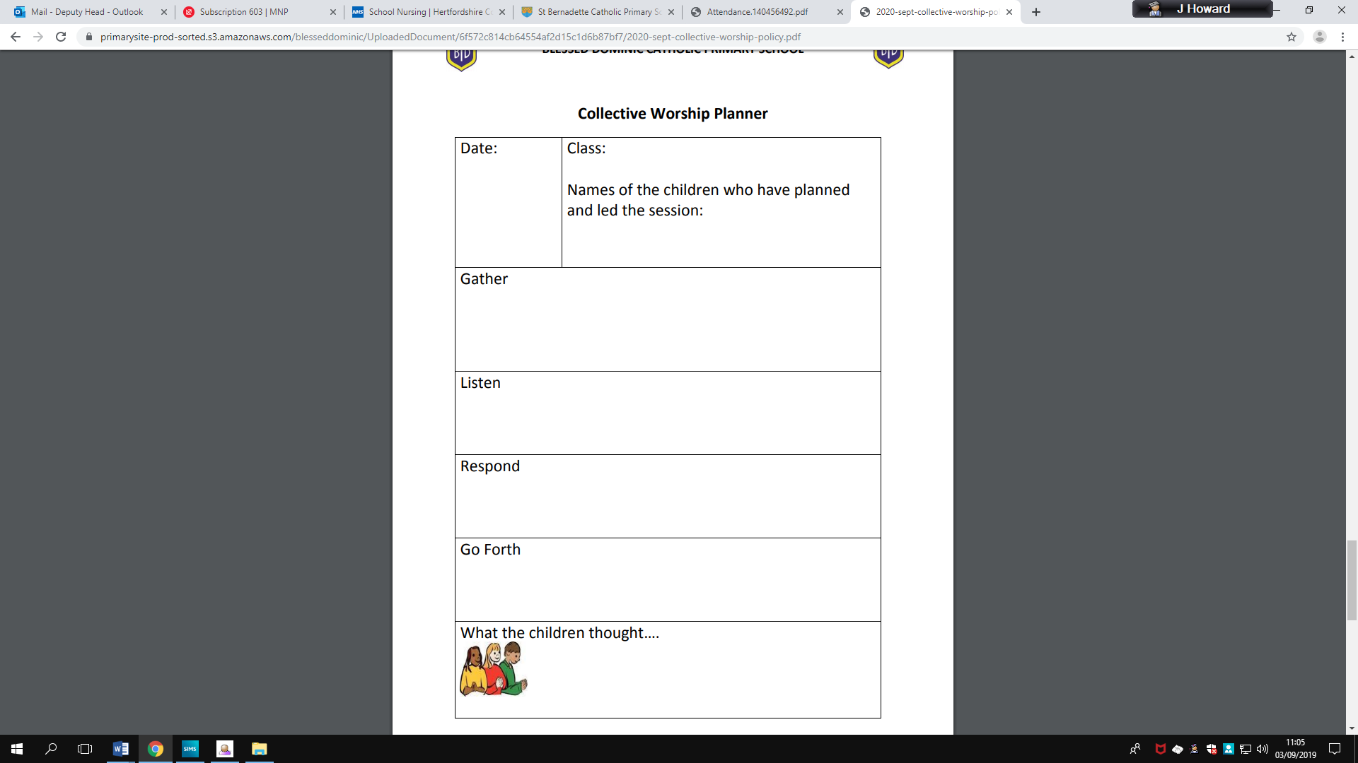

**Monitoring, Evaluation and Review**

We will review this policy annually with reference to the variety of experiences offered to our children. We will assess its implementation and effectiveness. This policy will be promoted and implemented throughout our school.