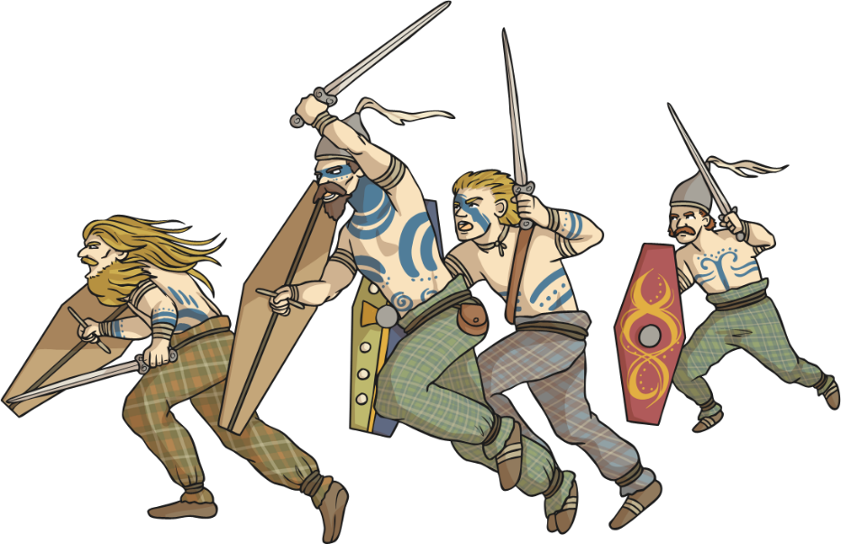
Thursday 8th October

LO: To explore life in Britain before the Romans invaded.

Today we will begin to learn about what Britain was like before the Romans came. This time was called The Iron Age because a group of Europeans had become expert at taking iron out of rock and making it into tools and weapons. These people were known as Celts. They came to Britain around 500 years before Jesus was born. This date is written 500 BC. The Celts soon spread and settled across Britain. The Celts lived in Britain happily until the Romans invaded! Let’s learn about the Celts…
- Go through the powerpoint all about the celts and make notes about what you have learnt in your homework books or in a notepad.
- Watch this video clip to learn some more about the Celts https://www.youtube.com/watch?v=_fP13qn6Bbc

Your task
Using all the information you have now been given about the celts your task is to write a diary entry imagining you are a celt! You could be a celtic warrior or a celtic farmer. Write about your daily activities and what you have done during the day, make sure you punctuate correctly, use adjectives and make them interesting! Read a part of my entry for some guidance and write yours below mine.

Dear Diary,
Today was a busy day! I woke up bright and early at around 6 in the morning, it was a chilly, miserable day so I hurried out of bed and put on my clothes for the day. I decided to wear my long, bright red dress that I had dyed using juicy berries yesterday. I also wore my beautiful bronze brooch that I made and pinned it to my dress. After I got dressed it was time to light the fire in the middle of the house, this made sure the house warmed up and so I could cook some food. I had to go and collect the food because we had run out from yesterday. I took a short walk to the fields and collected some corn, then I went to the chickens and collected some lovely, fresh eggs to cook…
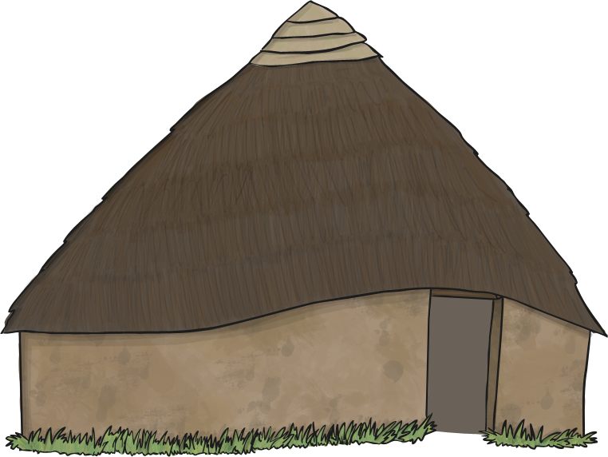

Now it’s time to write your own diary entry…

Dear Diary,

