The Ant and the Grasshopper
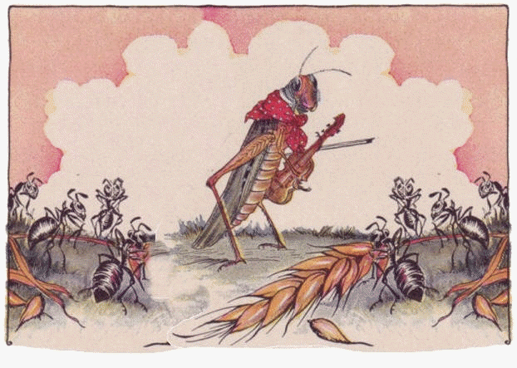

In a field on one hot summer’s day, a grasshopper was relaxing, eating as much grass as he possibly could. He ate so much that his stomach was full so he decided he would play some music. He picked up his violin and began to play a jolly tune, he was hopping around happily. Slowly an ant passed him by carrying a heavy ear of corn.

“Why don’t you come and sing with me?” called the grasshopper.
“No” replied the ant. “I am too busy collecting food to prepare us for the freezing cold winter, I recommend that you do the same.”

“Haha” laughed the grasshopper. “Why prepare for the winter? We have plenty of food and it is so warm, we should be enjoying the sunshine.”

But ant shook his head and went on his way. He continued to work hard all day and went back and forth carrying heavy loads of corn and grains.

“What a silly ant!” shouted the grasshopper. “He is really wasting his time, he should only worry about winter in winter!”

When winter finally came the snow was thick on the ground and the temperature had dropped and was now freezing. The grasshopper was so cold he couldn’t play his music, he couldn’t even hop. He was extremely unhappy and to make things worse he was starving! He had no food and there was no food for him to find. The ant however, had plenty of scrumptious food for himself and all of his family that he had collected in the summer.

The grasshopper slowly made his way to the nest of the ant, when he arrived he muttered “please may I have some of your food? Could you spare me some of your food?” begged the grasshopper.
“No!” shouted the ant. “You said I was silly and wasting my time!”

The grasshopper left and was hungry and cold all winter, he learnt a very important lesson.

