**St Bernadette Catholic Primary School**

**Special Educational Needs and Emotional Wellbeing Support for Home Learning**

**Zones of Regulation**

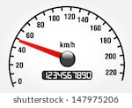Your body works like a car engine.

**Sometimes it runs on low speed.**

**Sometimes it runs on high speed.**

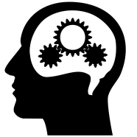**Sometimes it runs just right.**

Your brain controls the body “engine” through the neurons, the spinal cord, and nerves.

Your brain makes your body feel and act different ways.

****Your brain controls “The ZONES of Regulation”.



In the **Green Zone**, your body’s engine is running **“just right”**. You are **“good to go”.** You may feel **happy,calm and focused.**

****In the **Blue Zone,** your body’s engine is running on  **“low” or “slow”** speed.In the **Blue Zone,** you may feel sad, sick, tired, bored, or be moving slowly.



In the **Yellow Zone**, you need to proceed slowly with **“caution”** and be careful. You need to pause or stop to think. Read the signs…

Your ZONE of regulation is about to change !

In the **Yellow Zone**, you may feel **worried, frustrated, silly wiggly, and excited.**

**A ZONE CHANGE is COMING either . . .**

* To the calmer **Green Zone**
* Or to the out of control **RED ZONE**



The **RED Zone** is **extreme** . In the **RED ZONE**, you may feel **angry or mad, terrified, elated, or out of control**. You may feel like **yelling or hitting.**

****In the **RED ZONE**, your body engine is running on high speed.

You have trouble making good decisions and must **STOP.**

If you are stuck in a ZONE, then use a tool to change the zone.

**C:\Program Files (x86)\Microsoft Office\MEDIA\CAGCAT10\j0212957.wmfREMEMBER ...You are the driver in control of your body engine. You can change your engine speed.**

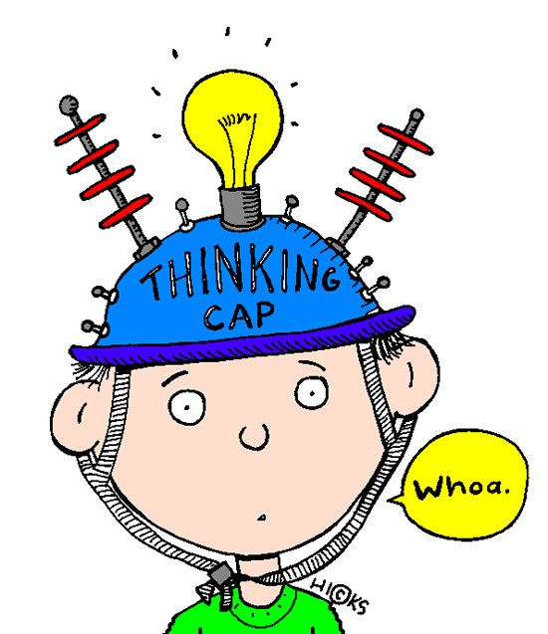

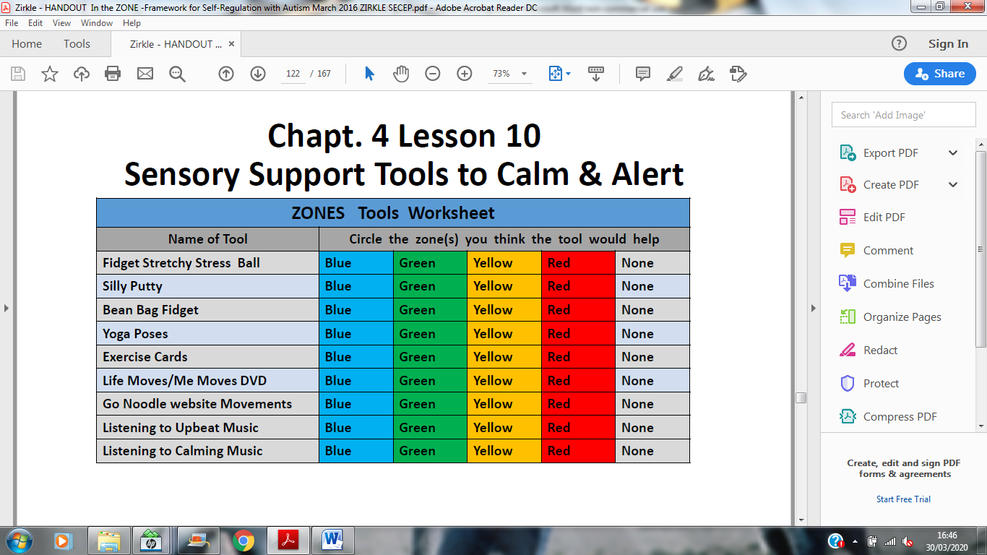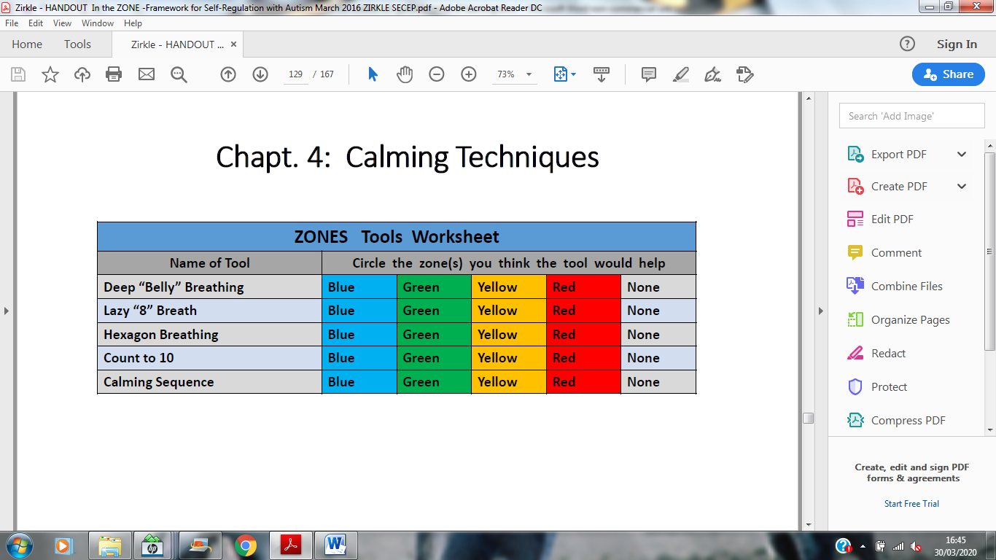

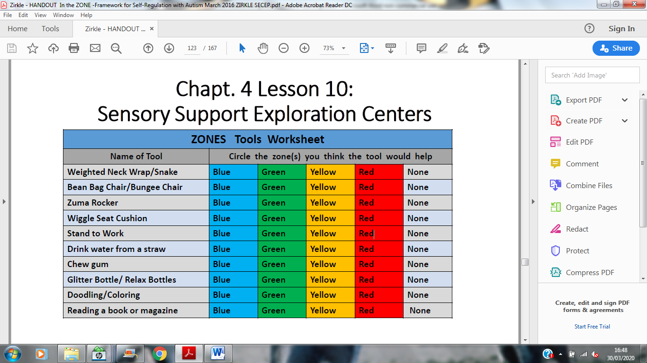

**Count to 10**

“1 hold steady,

2 hold steady,

3 hold steady, …

**10 I’m ready”**

Remember to think about the size of the problem too.





|  |  |  |  |  |  |
| --- | --- | --- | --- | --- | --- |
| Scale of problem | 1 | 2 | 3 | 4 | 5 |
| Type of problem | No real problem | Small e.g not being first in the line. | Medium  e.g change of plan , unexpected | Large e.g injury | Emergency  e.g disaster |
| Emotion | Calm , relaxed | Disappointed | Nervous , sad | Crying | Uncontrolled crying, scared |
| Action | Let it go | Have a go at fixing it yourself | Adult can help fix | Special adult to fix | Many adults to fix. |

The size of my reaction should match the scale of the problem.

In all our classrooms and around the school, we support children with a programme of Zones of Regulation - colours that help children identify what state of arousal they are at and where they would want to be.

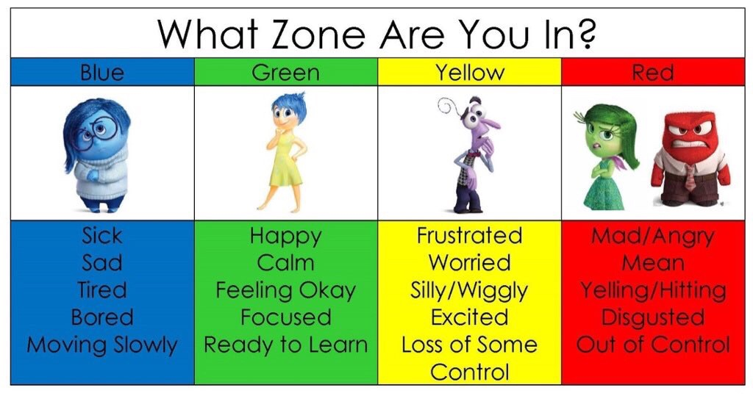

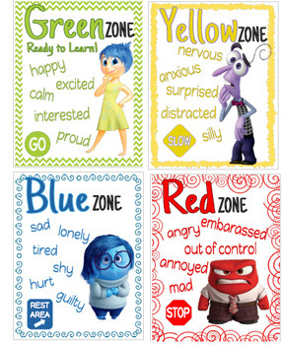

Work out a set of tools that helps your child. ( see the sensory tools of support above ) Everyone will be different. It might be :

* 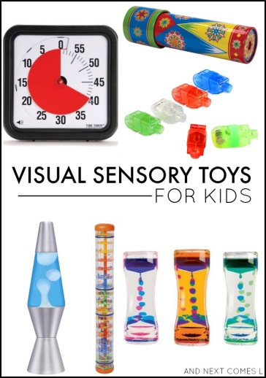going for a walk
* breathing and counting to 10
* cuddling a favourite toy
* bouncing on a trampoline
* colouring a picture
* using sensory tool such as fidget toys , lights, buddi ,

The film “Inside Out” is useful to use for clips to show how the emotions take control of the brain.

For children a cartoon step by step guide.

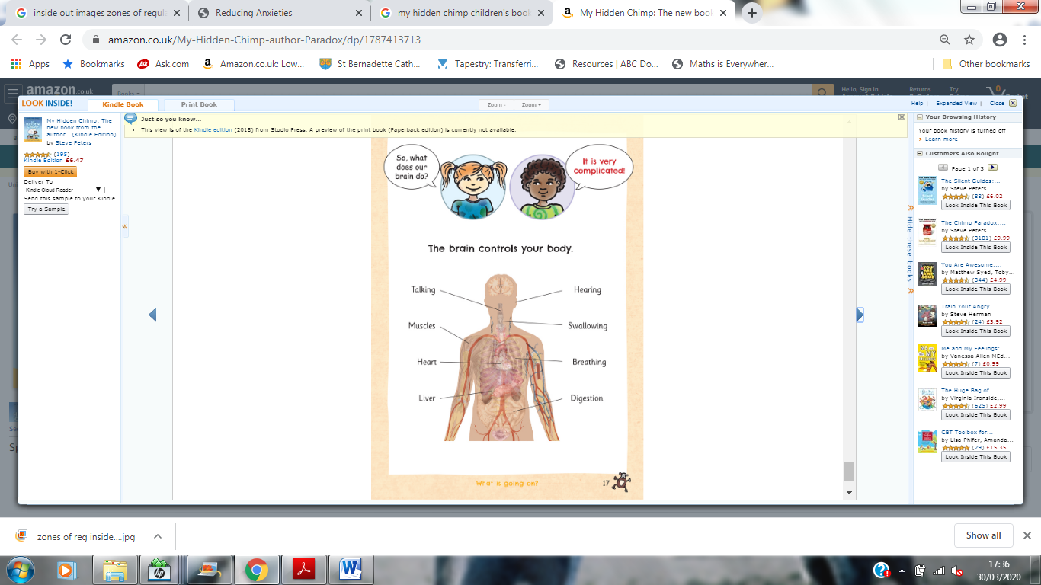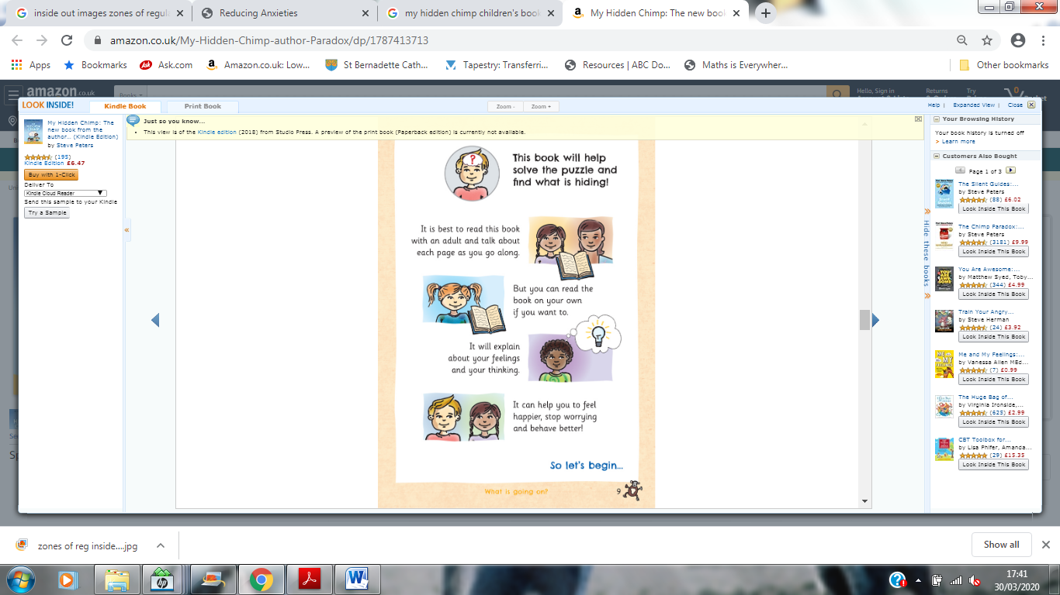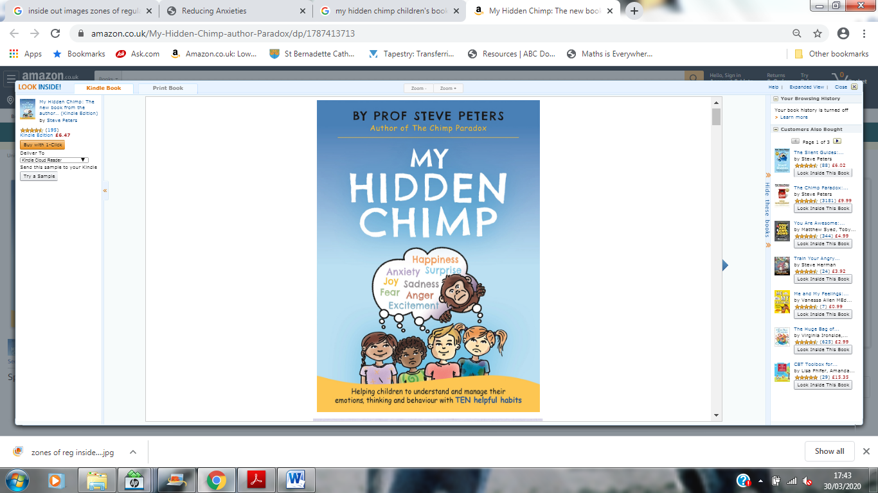

**References**

•Google Images

•Get Ready to Learn (Get Ready to Learn.com Yoga New York City Schools)

•GRTL pilot research analysis by NYU Department of Occupational Therapy in 2009/10 were presented to an enthusiastic audience at the AJOT Conference in Philadelphia in April 2011 by NYU professor DrKoenig, PHD.

•Kuypers, L. (2011). *The Zones of Regulation: A curriculum designed to foster self-regulation and emotional control.*San Jose, CA: Thinking Social Publishing, Inc.

•Life Moves DVD: Thinking Moves, LLC; website info@thinkingmoves.com

Thinkingmoves.com

•Novotny, S., & Kravitz, L. (n.d.). The Science of Breathing. Retrieved July 11, 2015.

•Novotny, S., & Kravitz, L. (n.d.). The Science of Breathing. Retrieved July 11, 2015.