Homework 13.11.20

Literacy:
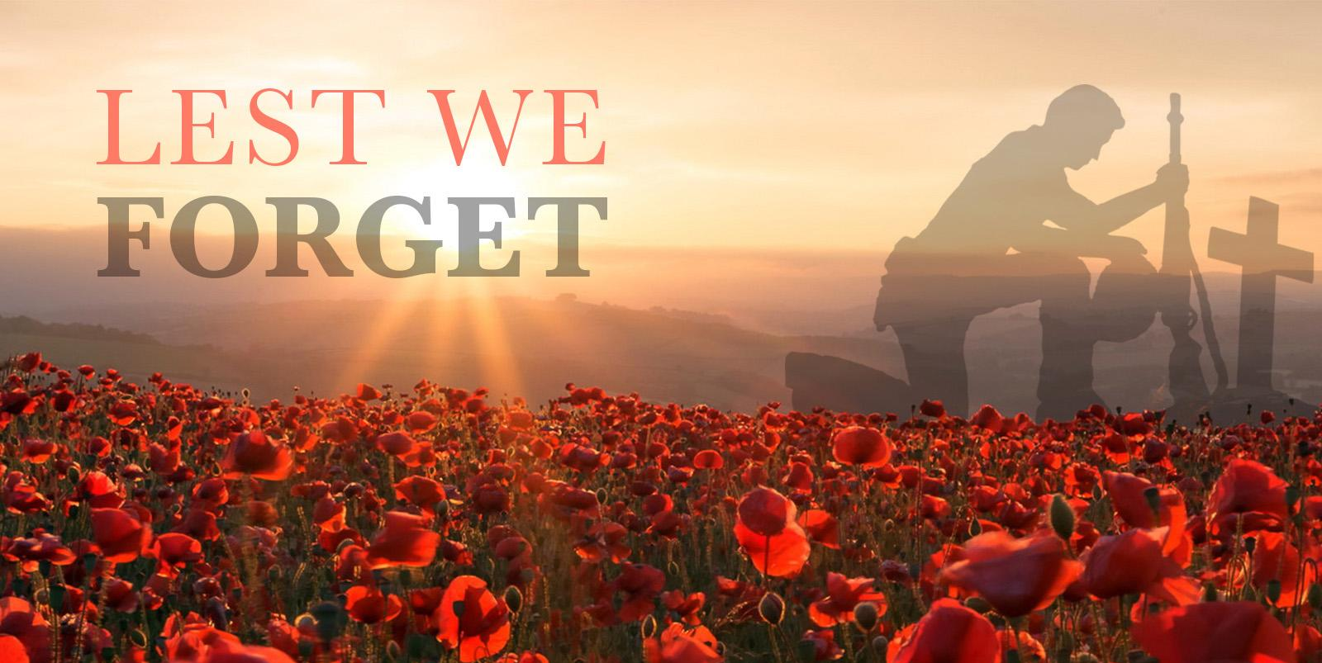
Once you have read the Remembrance Day reading comprehension sheet please answer these questions.

- How long did the first world war last?
- Where did beautiful red poppies grow?
- When did poppies first start being sold?
- Where does the money raised by poppy sales go?
- How do people take time to remember all those that died? Use evidence from the text to answer.
- Summarise why you think that Remembrance Day is important.

Spellings:
This week we are looking at spelling words using the prefix ‘un’. Please practise these spellings ready for your test next Friday. Use the look, cover, write, check model to help you learn them.

Group 1 | Group 2
unhappy | unhappy
unkind | untrue
unwell | unfair
untidy | unimpressed
unfair | unable
 | unpopular
 | unusual

Maths:

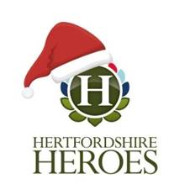
This week you have a task on MyMaths all about your 4 x tables! See if you can beat the clock and improve your time.

ART (COMPETITION)

This year, Hertfordshire Heroes are inviting students to create artwork to help bring “Christmas Cheer” to armed forces personnel working away from their families at Christmas, while highlighting the many different roles of the military.

For the 2020 competition we want to pay special tribute to the military for all the different work they do by asking children to create artwork about them.
Many armed forces personnel will be working in the UK and abroad, away from their families at Christmas time and we know that seeing the children’s artwork will help bring them some “Christmas Cheer”.

To enter the competition:

- Children should draw a Christmas picture which incorporates how the military supports us.

2. As part of their artwork, children should include the phrase, ‘Wishing our military heroes a Merry Christmas from (name of school)’.

3. Please hand in to me at the door (I will have a tray for them) by Wednesday 18th November.

