**Back to School Social Story**

**To stop people from sharing their germs and getting sick my school was closed.**

**I had to stay at home and stay safe.**

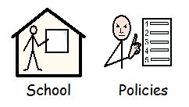**The Government who are in charge say it is safe for me to go back to school.**

**When I go back to school some things will be the same and some things may be different.**

**Things that will be the same –**

**The school building (add photo here)**

**The adults who work at school (add photo of familiar adults)**



**The children**

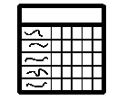

**My timetable**

**The way I travel to school (add photo/ symbol of appropriate transport)**

**Things that might be different –**

**Not all of my friends will be at school at the same time as me. This is ok.**

**My day might be shorter and I may not go to school every day. This is ok.**

**Here is a calendar showing which times and days I am going to go to school. If this changes my teacher and my parent/s will change my calendar (insert calendar here)**

[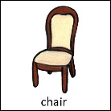](https://www.google.com/url?sa=i&url=http://www.mypecs.com/pecs_163/chair.aspx&psig=AOvVaw2rAbxlI55kAgoFUFPUnzlz&ust=1589463851373000&source=images&cd=vfe&ved=0CAIQjRxqFwoTCKjI0L38sOkCFQAAAAAdAAAAABAE)**I might sit in a different seat. My teacher will show me where to sit. This is ok.**

[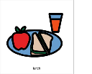](https://www.google.com/url?sa=i&url=https://boardmakeronline.com/Activity/2858072&psig=AOvVaw3zIquPo9qCY29HDmlask2j&ust=1589464065065000&source=images&cd=vfe&ved=0CAIQjRxqFwoTCNjol579sOkCFQAAAAAdAAAAABAD)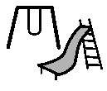**I might have different lunch and playtimes. This is ok.**

**There might not be assemblies.**

[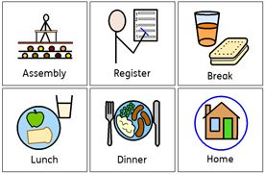](https://www.google.com/url?sa=i&url=https://www.pinterest.co.uk/pin/358317714083604816/&psig=AOvVaw2u_joukwfzaTTvf_H7TCjS&ust=1589464192760000&source=images&cd=vfe&ved=0CAIQjRxqFwoTCLjm9N39sOkCFQAAAAAdAAAAABAD)

**Sometimes change makes us feel worried or sad, that’s ok.**

**Everyone feels worried sometimes.**

**If you are worried you can tell someone who cares for you, a teacher or your Key Worker or your parents. They will listen to you and help you to be less worried.**

[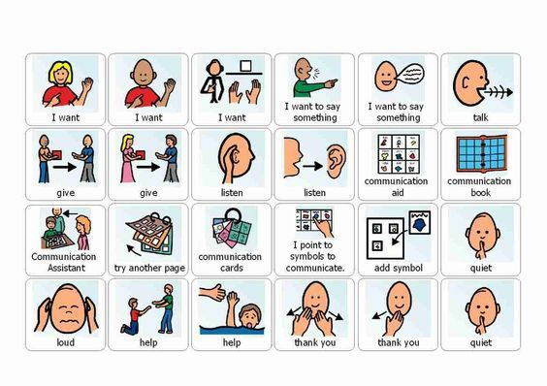](https://www.google.com/url?sa=i&url=https://www.pinterest.com/pin/34269647150010303/&psig=AOvVaw0IxzF1uKUKxZ_Px9jY7Yzu&ust=1589464396110000&source=images&cd=vfe&ved=0CAIQjRxqFwoTCKiVt8X-sOkCFQAAAAAdAAAAABAD)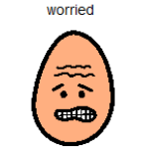

 **All children need to go to school to learn and practice new things. It is good to go to school.**

**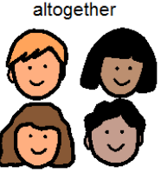****When the government says it is ok schools will start to go back to normal with all my friends and teachers coming to school every day. My parent/s and teachers will tell me when this is going to happen. It is ok, it is good to go to school.**