heart beats per minute recording sheet
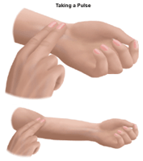
Count your pulse for 10 seconds and then multiply this by 6 to see how many times your heart beats in a minute. Complete each activity and then straight after doing the activity for 1 minute immediately check your pulse. Count how many times you can feel it beat in 10 seconds and then multiply this to see how many times your heartbeat per minute. I wonder how your heart rate will change when you do different activities!!

Activity | Beats in 10 seconds | Beat per minute (multiply the beats in 10 secs by 6)
Sitting
Slow breathing
Walking
Jogging
Jumping
sprinting

Once you have completed the recording sheet:
- What activity made your heart race the most?
- What activity made your heart race the least?
- Can you research and explain why our heart race increases when we do exercise?

