Year 6 Literacy homework 25-09-20
The Submerged City
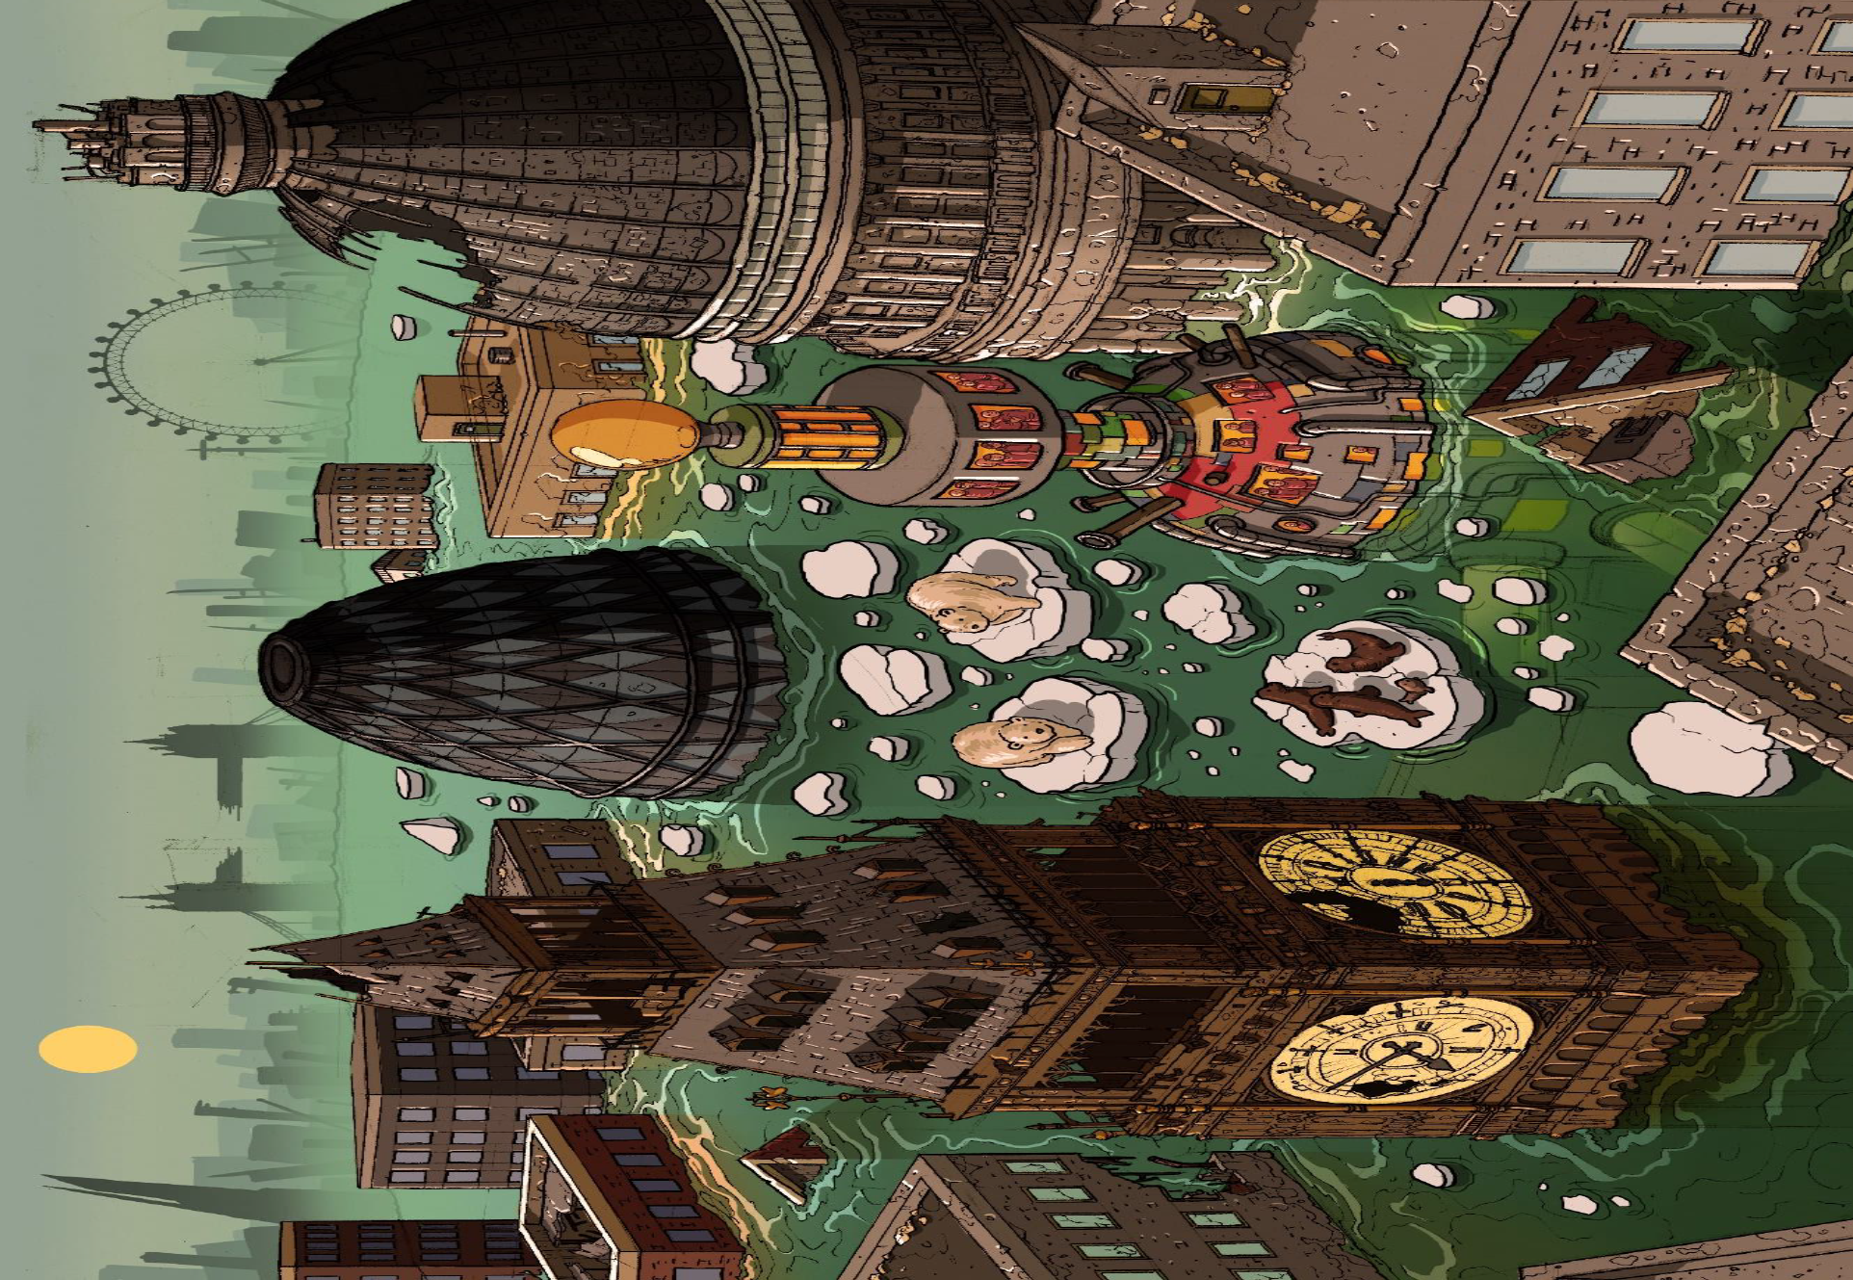
(Click under each question to add your answer).
1.
Can you identify the city? What clues are there to suggest this?

2.
Is there anything unusual in the picture that you wouldn’t normally expect to see?

3.
Where would you normally expect to find the animals that are present in the
image?

4.
What do you think has caused the flooding?

5.
Do you think this is a real picture of possible future events? Why/why not?

6.
What do you notice about the unusual tower? Why do you think it was built?

7.
Do you think the tower is large enough to provide sanctuary for the whole
population? If not, what has happened to the rest of the people?

8.
Summarise this image in a few, well chosen sentences.

9. If this was a story, what could the title be?

