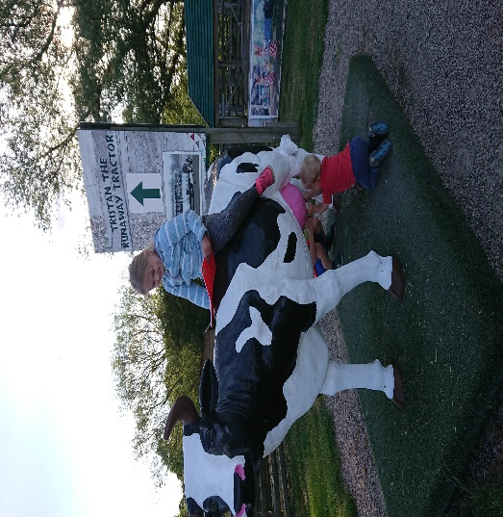

Reading Challenge!

Olivia reading a book on a cow!

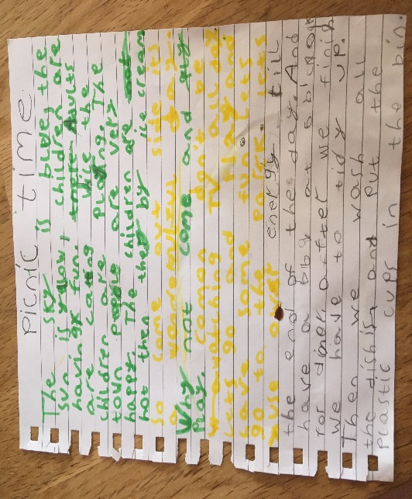

Additional work – story about special time.

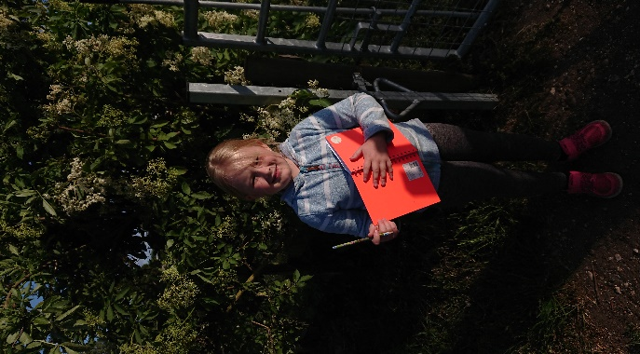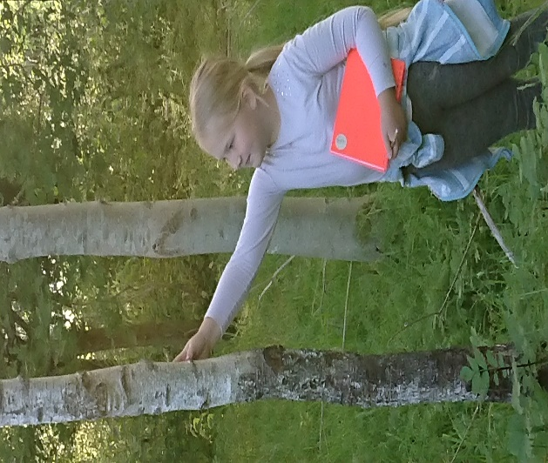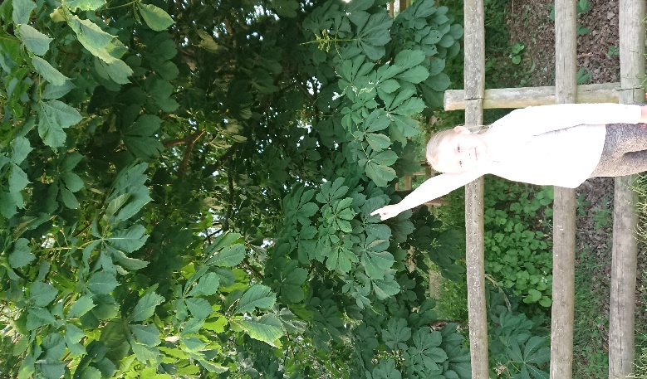

Olivia undertaking the challenge: “Get to know the tree”

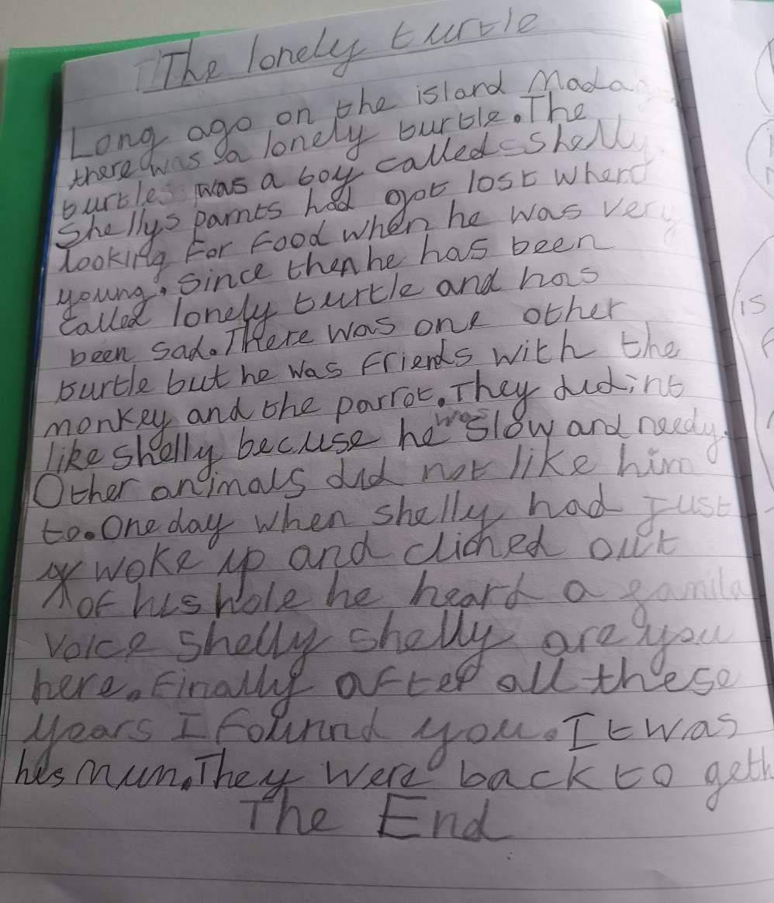 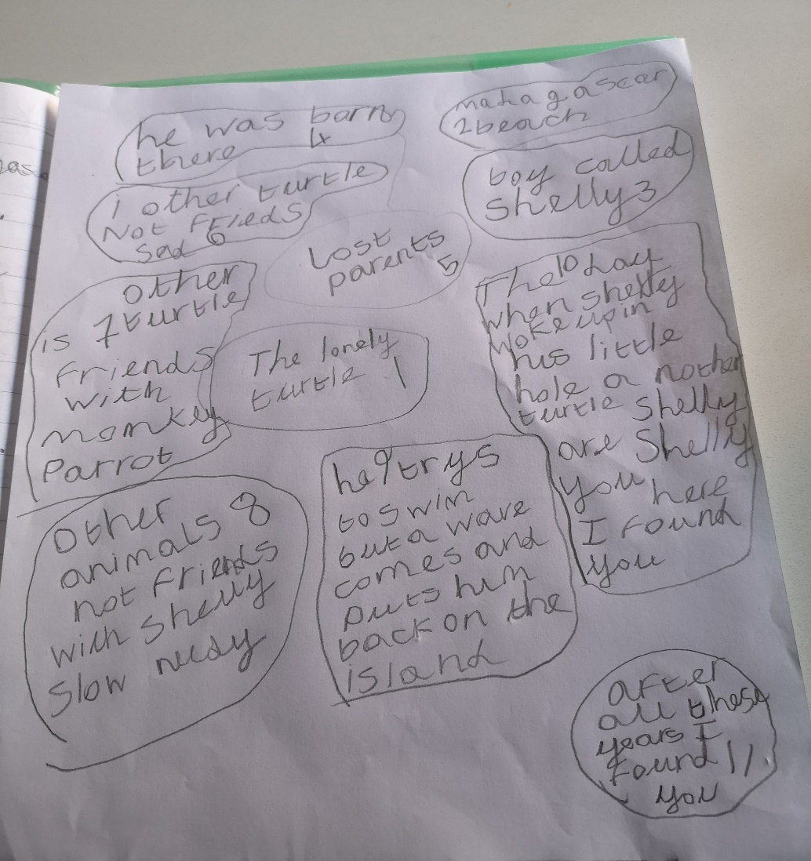

Sofia used a story map to write an exciting story about the lonely turtle! Good work, Sofia!

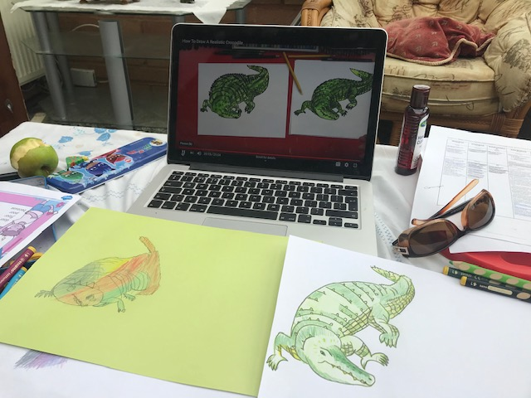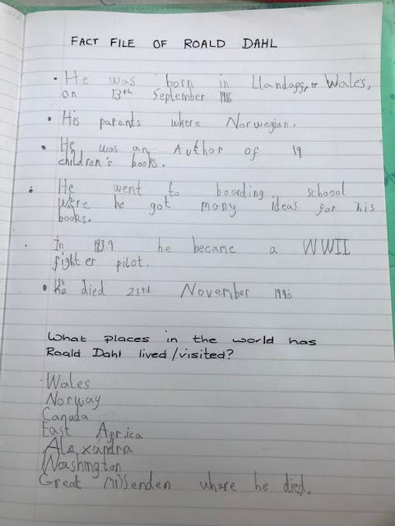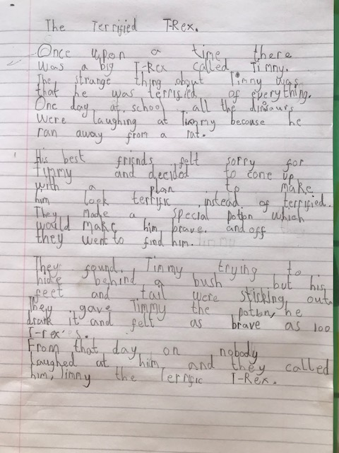

I have really enjoyed learning about Roald Dahl and I had lots of fun trying to draw the crocodile

said Cian. He also wrote a great story about a dinosaur and a fact file about Roald Dahl. Great work Cian!

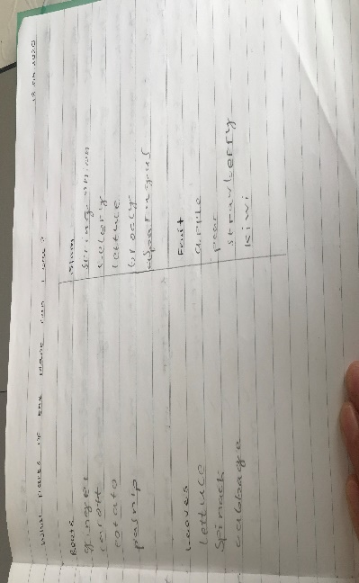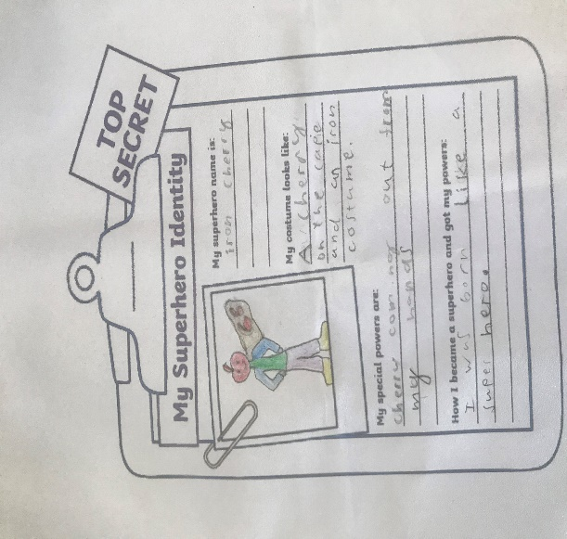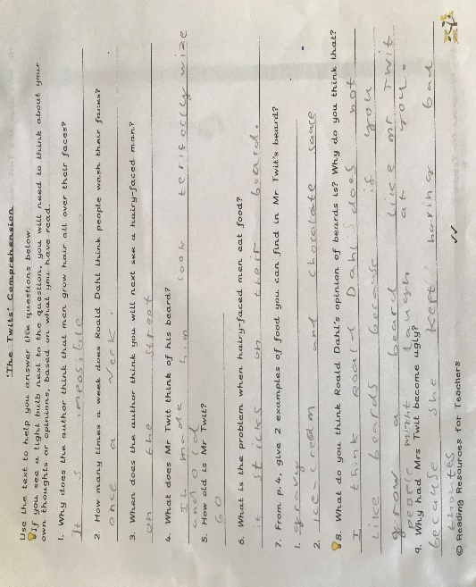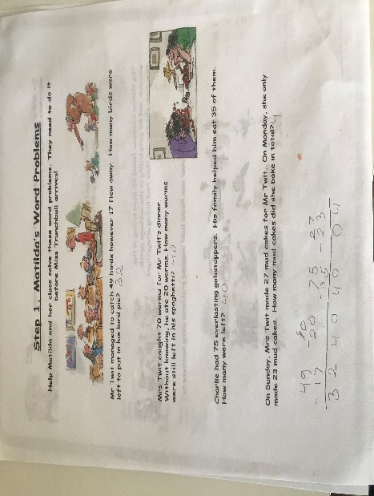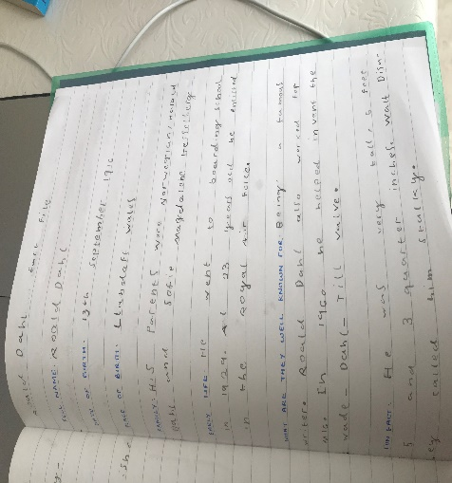 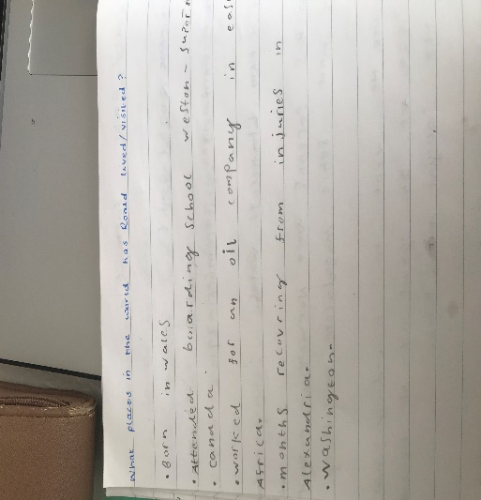

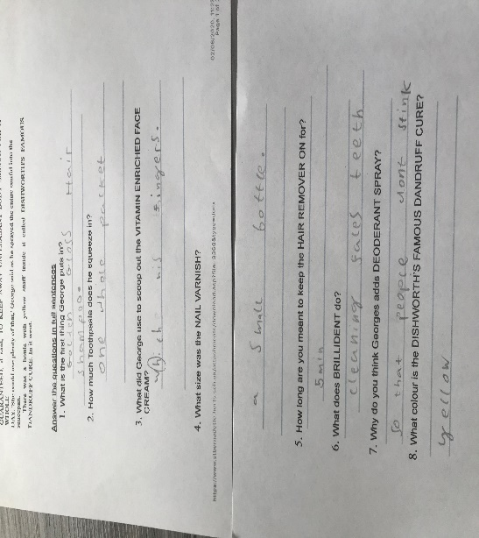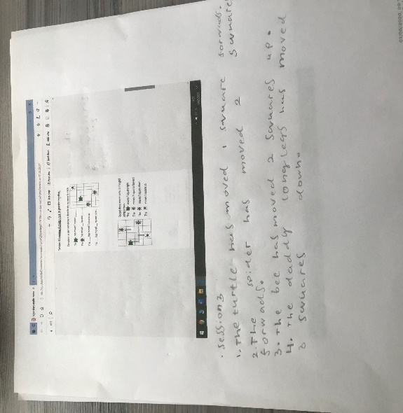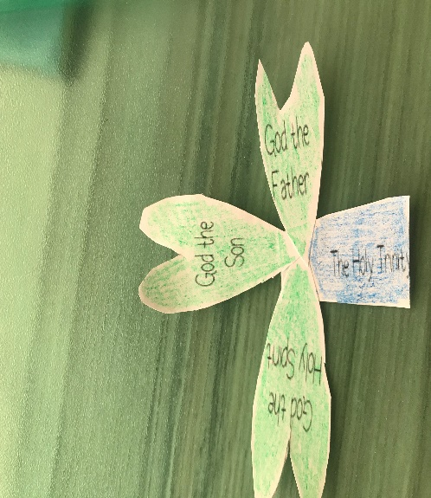

Did you know?

Valentino really likes Roald Dahl and he is working through reading all his books. Wonderful!

Valentino- I can see how well you are working at home and I really enjoy reading your work. Your shamrock is so lovely. Thank you

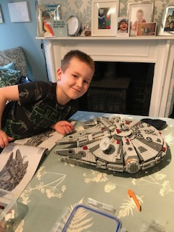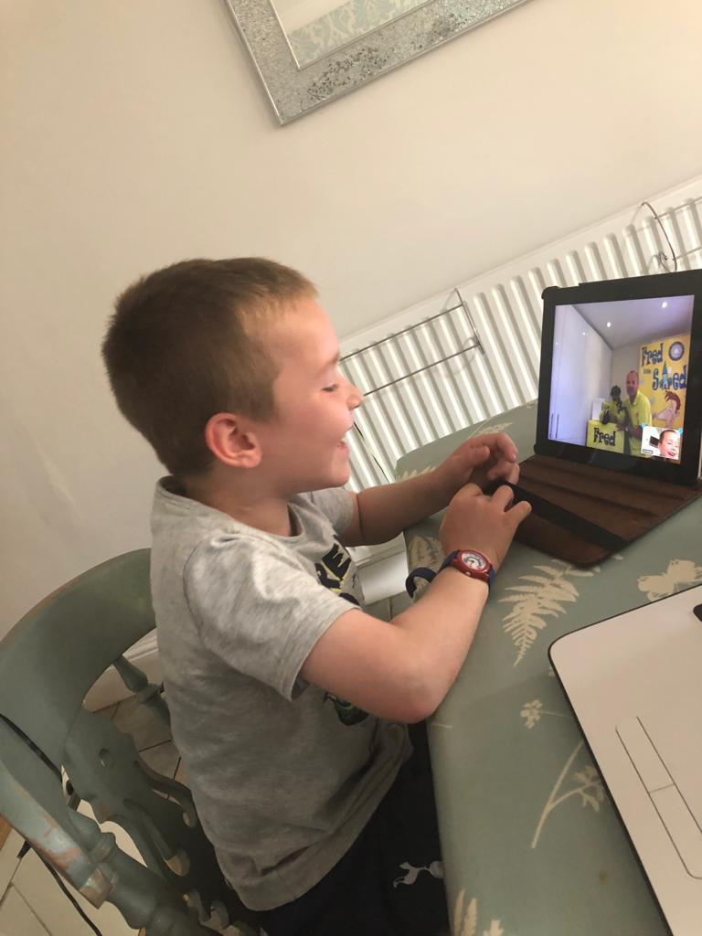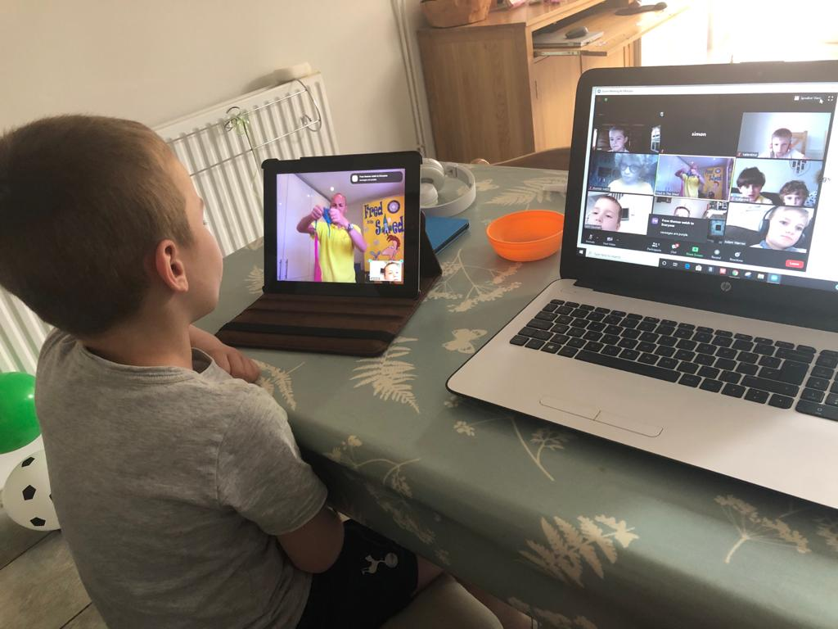

On Wednesday was Jem’s birthday. On that day he had a little zoom party with some of his friends and a magician for entertainment! He got a huge Star Wars Lego Millennium Falcon spaceship as his present which has taken him 3 days to build!