Separation Anxiety
Useful links
https://www.nhs.uk/oneyou/every-mind-matters/childrens-mental-health
https://www.nhs.uk/live-well/sleep-and-tiredness/healthy-sleep-tips-for-children/
What is it?
Separation anxiety is a term used to explain a feeling of anxiety or stress when you are away from your parents/family/guardians, for example, when you are at school. You may find that you worry a lot when your parents or guardians are not with you or when you are away from your home. This will affect how you act towards other people when you are in certain places such as school. You may only feel comfortable and stop worrying when you are at home or with your parents/guardians. You may also feel afraid of going to sleep alone and when you do get to sleep, you may have nightmares about being apart from your parents/guardian. You could sometimes have a tummy ache or headaches when you are away from your parents and you may also create stories, like saying that you don’t feel well to avoid being away from your parents or your home
Symptoms of Separation Anxiety Disorder
Symptoms of separation anxiety occur when a child is separated from parents or caregivers. Fear of separation can also cause anxiety-related behaviours which can progress into adulthood. Some of the most common behaviours include:
- Clinging to parents
- Extreme and severe crying
- Refusal to do things that require separation
- Physical illness, such as headaches or vomiting
- Violent, emotional temper tantrums
- Poor school performance
- Refusing to sleep alone
- Nightmares
There are times when we all feel the strain. As parents and carers, there are ways we can support children and young people to give them the best chance to stay mentally healthy.
Some children and young people have enjoyed being off school, while others will have really struggled – with the coronavirus outbreak keeping them at home and away from friends. Others may be coming to terms with family problems, loss or changes to their living situation.
As restrictions lift in some places, they might also face difficulties in being back at school or college, or have worries about getting or passing on the virus. It's also still uncertain what further changes we all may face.
Feelings like these will gradually ease for most, but there are always steps you can take to support them emotionally and help them cope with problems they face.

The following can help children with separation anxiety:
• Having a transitional object. “A transitional object is something that can be used to remind the child that even though they are separated from their parent, they can continue to hold them in mind and feel their connection with them” Examples of transitional objects include: a bracelet; photo of the parent; a kiss drawn on a hand; perfume sprayed on the child’s shirt; a note in the child’s lunchbox; a cuddly toy; an small item of clothing belonging to the parent
• An organised “Meet and greet” from a key person at the start of the day that follows a regular routine. Having a key person can help the child cope because they serve as a substitute attachment figure in school
  - • When dropping the child off, the parent should: o pass the child to a trusted adult
have a clear routine for saying goodbye to their child (e.g. a kiss on the head and a clear goodbye) so the child knows exactly what is going to happen.
reassure the child that they will see them later
give the message they believe the child cope
be kind but firm, and not give in if the child becomes upset
Leave quickly without drawing out the goodbyes or “sneaking away”.

  - • A “soft start” to the day where the child does a fun activity with the key person prior to going into class. Alternatively, consider a “busy bag” for child to do when they first come into the classroom to distracts them from their worries.
  - • A visual timetable so the child knows what will happen and when they will see the parent again.

  - If the young person is beginning to school refuse, consider adapting some of the usual routines that trigger negative emotions to make it easier for the child enter the school building. For example: consider a later start time or using a different entrance; have a “meet and greet” with a set routine; encourage a peer to accompany them to school to distract them from negative thoughts on the journey; introduce a visual timetable so they know what is going to happen throughout the day and point out any unexpected changes in advance
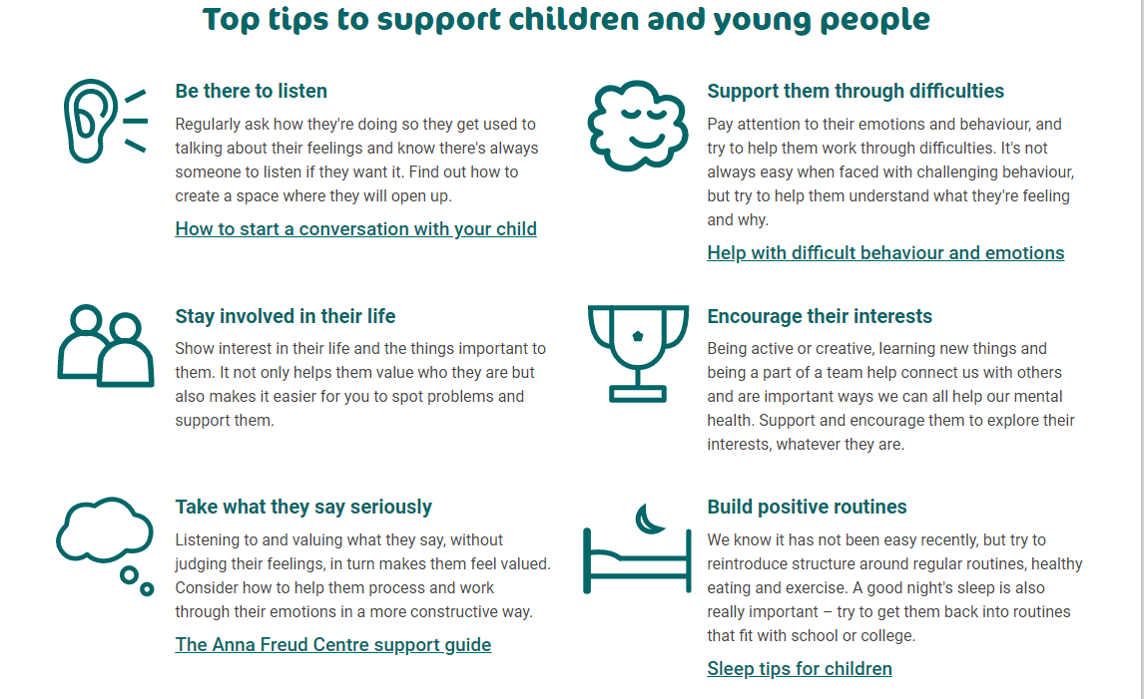

Good books to read to children to explore separation anxiety include:
• The kissing hand
• The invisible string
• Owl babies
• The kiss box
• Huge bag of worries

Families under pressure

https://maudsleycharity.org/familiesunderpressure/

This has videos and top tips that support families going through challenging behaviours . “During this stressful and cooped-up time, don’t let the pressure of parenting get you down. Try these simple tips and tricks, formulated by researchers and NHS mental health experts, which are backed by science and proven to work with families.”

Going back to school

While some children and young people will have been looking forward to going back to formal education, others will not have.
The changes brought in because of the coronavirus (Covid-19) outbreak – like social distancing, improved hygiene, smaller classes and the possibility of not seeing some friends – may leave them feeling strange about being back.
Some may also have other worries, such as school-based anxiety or problems with bullying, or be dealing with big changes, like starting at a new school or college.
For those with additional needs, the changes to school life might be particularly upsetting and, as a parent or carer, you might need more support too.
How do they feel about being back?
It's easy to think we know how the children and young people we look after feel about going back to school or college, but this might be an assumption based on how we feel about it. Though we have all been in lockdown, every family's experience will have been different.
Try reflecting on how it's been for them to be away for so long, and ask if there's anything in particular they're enjoying, looking forward to or worried about.
For younger children, you could try asking them to draw or paint what being back at school is like. For older ones, try asking them what 3 things they're thinking about most.
If they're anxious or have mixed feelings, let them know this is nothing they need to hide or be ashamed of and that others will be feeling the same.
There's likely to be a lot of uncertainty around school life now, so listening to their thoughts will be really helpful. Reassure them that whatever they're feeling is understandable and reasonable.
Try to resist any urge to have all the answers. The more we can all build resilience for uncertainty at this time, the better.
No one knows exactly how the next few months will be – but it's important to reassure them these changes will not be forever, and you will be there to help them deal with whatever happens.
The Schools and Families Advice Line (0300 777 0707; hpft.spa@nhs.net) is also available for advice around:
- • General concerns around mental well-being, coping strategies and self-care
- • How to support children and young people in relation to the Covid-19 outbreak (e.g. understanding, frustration, anxiety etc). Supporting mental well-being during the transition back to school and the anxiety around this uncertainty
- • Support and advice for education staff around their own mental well-being
- • ‘Whole school approaches’ to supporting mental well-being
- • Specific anxieties (around COVID-19/self-isolating measures, transition between year groups, developing and maintaining relationships, fear of failure, low self-esteem or aspirations, trust issues, social anxiety, etc.)
- • Phobias (animals/insects, specific food stuffs, specific objects, modes of transport etc.)
- • Low mood
- • Emotional regulation difficulties.
- • Mild obsessive-compulsive difficulties that are starting to impact day to day activities.
- • Low-level behavioural concerns
- • Sleep difficulties
- • Signposting to services and resources that may be helpful for supporting mental wellbeing.

Good sleep is important for your child's physical and mental wellbeing.
A relaxing bedtime routine is one important way to help your child get a good night's sleep.
Relaxation tips to help sleep
Doing the same relaxing things in the same order and at the same time each night helps promote good sleep:
- A warm (not hot) bath will help your child relax and get ready for sleep.
- Keeping lights dim encourages your child's body to produce the sleep hormone, melatonin.
- Once they're in bed, encourage your child to read quietly or listen to some relaxing music, or read a story together.
- You could also suggest your child tries this relaxing breathing exercise before bed.
Know how much sleep your child needs
The amount of sleep your child needs changes as they get older.
A 5-year-old needs about 11 hours a night, for example, while a 9-year-old needs roughly 10 hours.
See how much sleep your child needs.
Avoid screens in the bedroom
Tablets, smartphones, TVs and other electronic gadgets can affect how easily children get to sleep.
Older children may also stay up late or even wake in the middle of the night to use social media.
Try to keep your child's bedroom a screen-free zone, and get them to charge their phones in another room.
Encourage your child to stop using screens an hour before bedtime.
Your child's bedroom
Your child's bedroom should ideally be dark, quiet and tidy. It should be well ventilated and kept at a temperature of about 16 to 20C.
Fit some thick curtains to block out any daylight. If there's noise outside, consider investing in double glazing or, for a cheaper option, offer your child earplugs.
Get help with sleep problems
If you've tried these tips but your child keeps having problems getting to sleep or sleeping through the night, you may feel you want more support.
You can speak to your GP or health visitor to begin with. They may refer you to a child psychologist or another expert.

