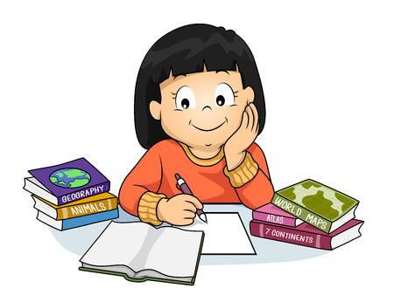
Year 3 Homework

Good luck with your first homework of year 3, remember to just try your best and remember to press ‘turn in’ once you have finished your work :)

Spellings
This week we are looking at the suffix ‘ed’. Practice writing your spellings out and use ‘look, cover, write, check’ to see if you are spelling them correctly!

Danced
Yelled
Kicked
Printed
Mixed
Helped

Times Tables
This week we are practicing our 3 x tables. You can have some fun practicing using the hit the button game following this link
https://www.topmarks.co.uk/maths-games/hit-the-button

(click on times tables and then choose the 3 x tables)

Write out your 3 x tables in your books and practice with someone over the weekend.

Literacy
Answer the questions based on the image below, make your answers interesting and remember to include full stops, capital letters and a range of interesting adjectives.

- Do you think the trolls are friendly or not? Explain why.
- How will people feel about seeing the trolls?
- How will the trolls feel about seeing people?
- Where do you think the trolls have travelled from?
- Why do you think they have come here?
- How would you deal with the trolls if you had to?

Maths
Complete the task on mymaths for this week, you are looking at number sequences and identifying the pattern to fill in the missing numbers.

