We have been inside because of Coronavirus. Coronavirus can make people feel very unwell.

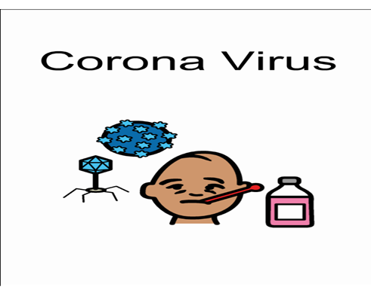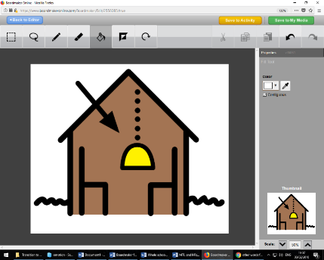

To make sure we can help people stay safe, we have to be socially distant from others unless they live in our houses.

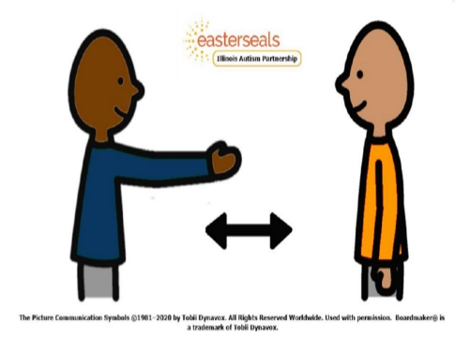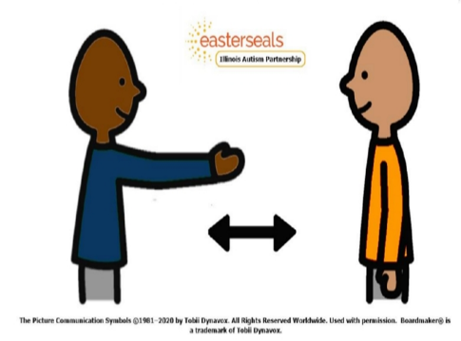

Social distancing means we have to stay two meters away from people when we are out in public.

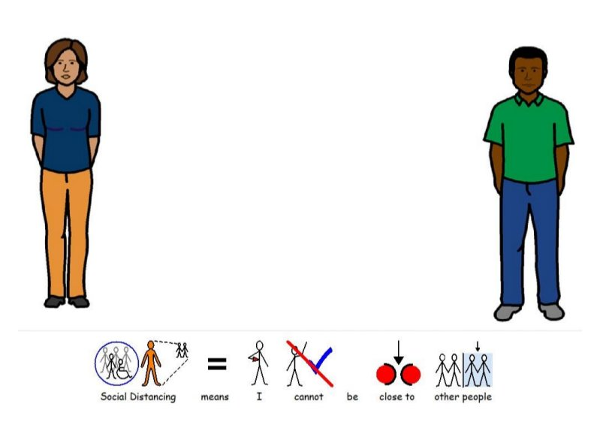

**2 Meters**

When the government says we can go back to school, we will still have to practise social distancing when it is possible and we will need to wash our hands more often.

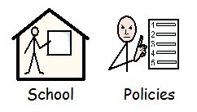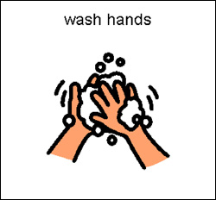

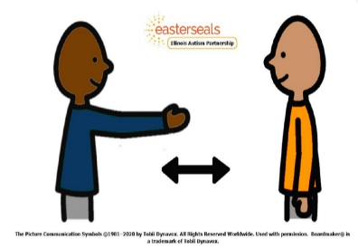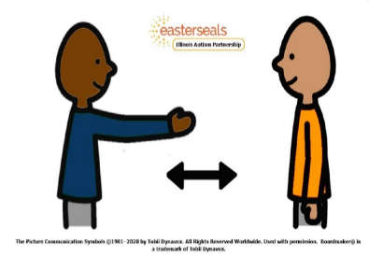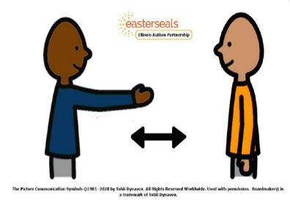

Social distancing will help to keep us safe

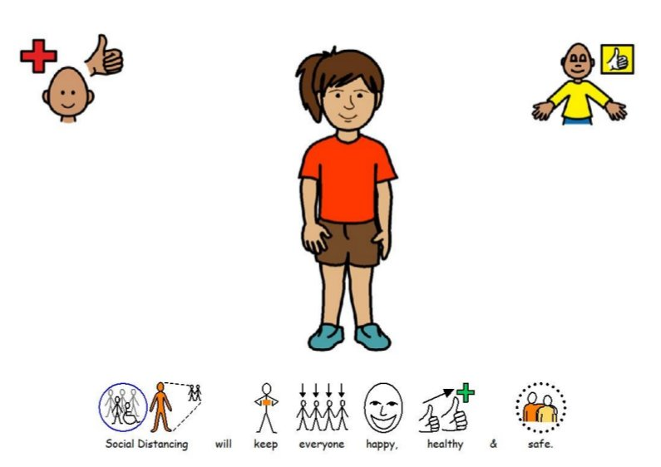

It will feel strange because I cannot hug, high five or touch anyone who does not live in my house

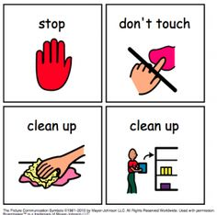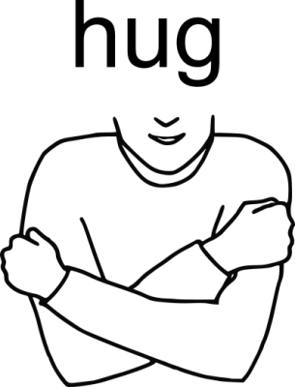

Washing our hands will help us safe too

We must wash our hands for 20 seconds using soap and water

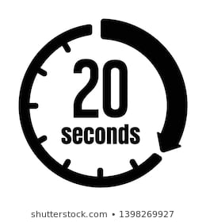

Things may feel different for a while, this might make me feel sad or worried

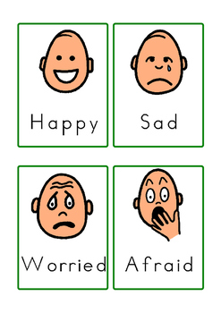

If I feel sad or worried I can talk to my parents or my teachers and they will help me feel happy and calm

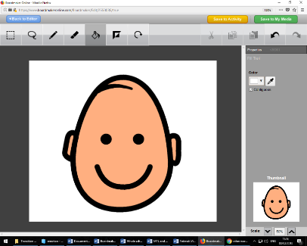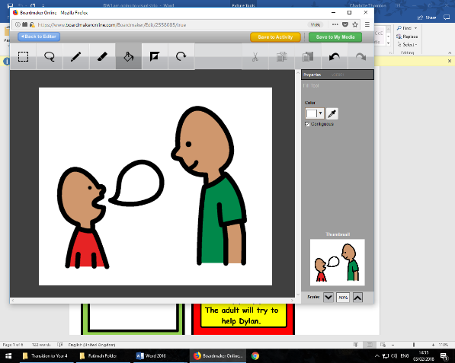

Social distancing may be strange but it will help keep everyone happy, healthy and safe.



